16.65: a) 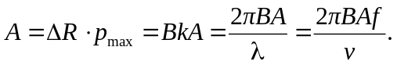 In air 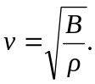 Therefore 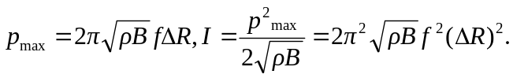
b) 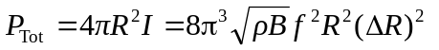
c) 